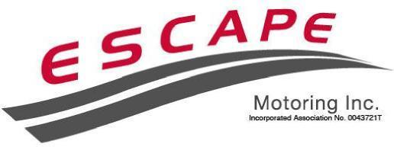
History of Escape Motoring
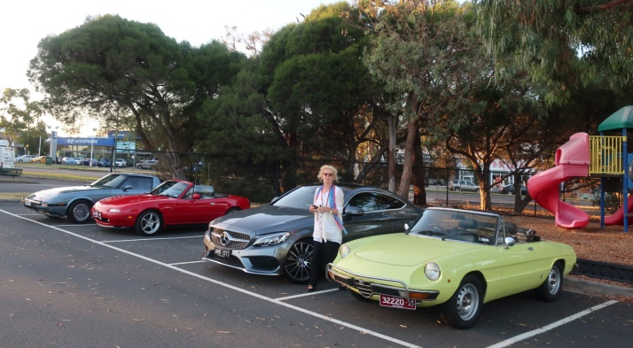
Escape Motoring is a club for people who like driving their motor cars, particularly sports car or cars with a sporting character. It is unlike other Clubs in that we do not have meetings where we sit down and discuss how the club is run, read minutes or debate issues. Instead we meet and go for a drive. Our Club is about enjoying the drive.

Long time MG and Morris enthusiast, Neil Wakeman, used to go on solo early Sunday morning drives in the countryside to the east of Melbourne. Rugged up in a warm jacket, scarf and gloves, Neil’s regular Sunday morning ritual was a brisk run to Yarrambat to share a breakfast cuppa with a friend, or a drive up through the beautiful Yarra Valley to Healesville, or a spin out the back of Warrandyte or Wonga Park, in either his topless MGB or Sprite, summer and winter. A regular stopping off point was at Sugarloaf Reservoir, where he'd pause briefly for a chat with the kangaroos, rabbits and a bloke on a big BMW motorbike who also enjoyed early morning driving.
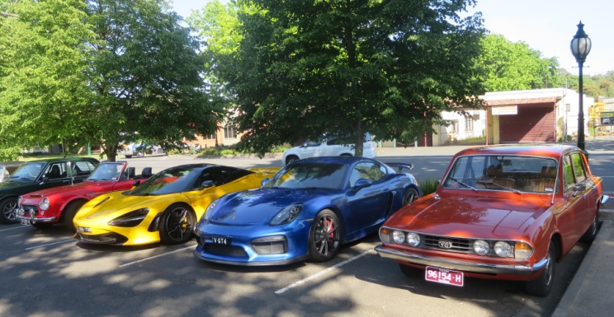
Neil had been doing this on his own for a couple of years or so, when a friend, Mike, asked if he could come along one Sunday, in his Sprite. Then Mike's neighbour Henry, who lived down the street, joined with his big Healey. The word soon spread and before long, there was a whole gaggle of mature aged blokes in mature aged sports cars enjoying early morning drives.

As numbers grew, this group of enthusiasts started referring to themselves as the ESCAPE Group - 'escape' seemed a pretty good word, as it was what they did most Sunday.

But at the last run for 2002 there were more than 45 cars and it occurred that there could be some legal problems if something went wrong on a run. Would one of the organisers be blamed. So legal advice was sought and this confirmed that concern. As a consequence ESCAPE Motoring was incorporated on 10 February 2003 and became a member of the Association of Motoring Clubs Inc. (AOMC). This provided some legal protection with Public Liability, Associations Liability & Voluntary Workers Insurance.
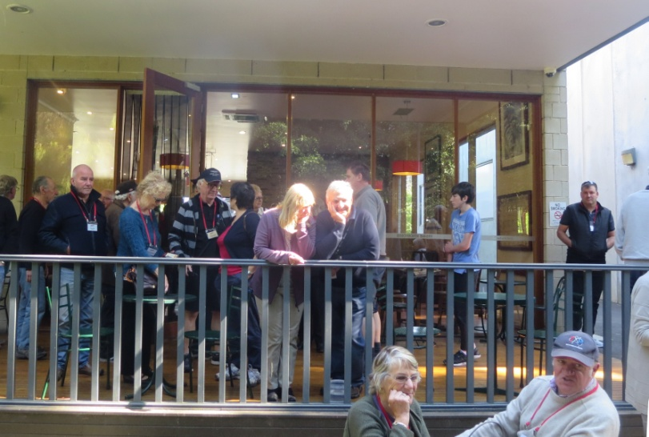
Since incorporated Escape has organised an Early Moring Run on the second Sunday each month, rain, hail or shine. Runs commenced at 7.15 am start from the Mitcham Football Oval or some other nearby location (recently it was decided that during winter runs should start at 7:45). Route instructions are sent to members via email with one clear instruction - if you are late, we don’t wait. Some people miss the start and join the run on the way or, those that sleep in, go straight to the destination.

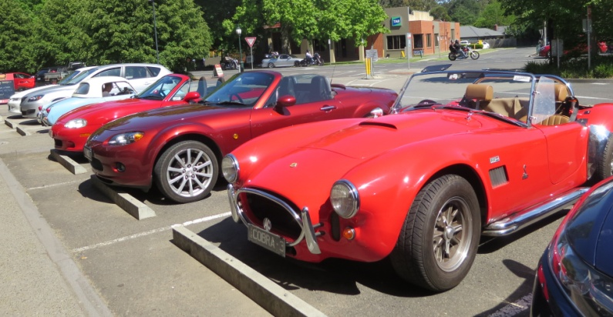
Runs are usually of about 1½ hour duration, through the beautiful picturesque Melbourne countryside. Often we go through the hills surrounding Melbourne but sometimes we go a bit further such as down to the seaside. Where ever we go we finish at a Wig Wam Stop for morning tea/coffee and something to eat (sometimes we stop in a park and other times in a cafe) and a chat. By the way, a Wig Wam Stop is short for a cup of Tea and a Pee.

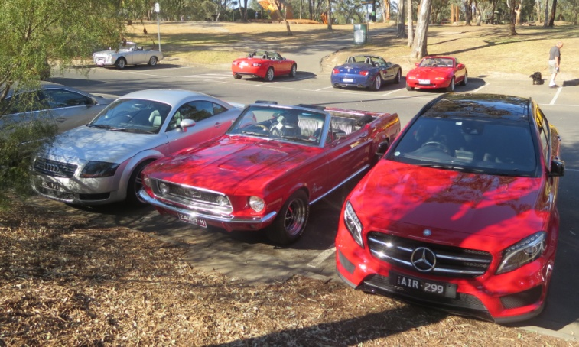
ESCAPE also organises a mid-week run each month. These runs provide an opportunity to venture into the country for a hearty pub meal and a chance to socialise with other ESCAPEEs.

Escape Motoring can approve Club Registered cars, although we only approve cars where the owner has been a member of Escape for a minimum of 12 months and has been a regular attendee at Club runs. This is as we believe the current Club registration scheme is a very good one and we want to ensure that only regular club members use it.

ESCAPE does not compete with other car clubs in Melbourne, and many ESCAPE members also belong to other clubs. We don’t have meetings, competitions, concourse displays, track days trials, or similar activities. Instead ESCAPE is simply about enjoying driving our special cars, and sharing that enjoyment with friends, all of whom have the same interest.
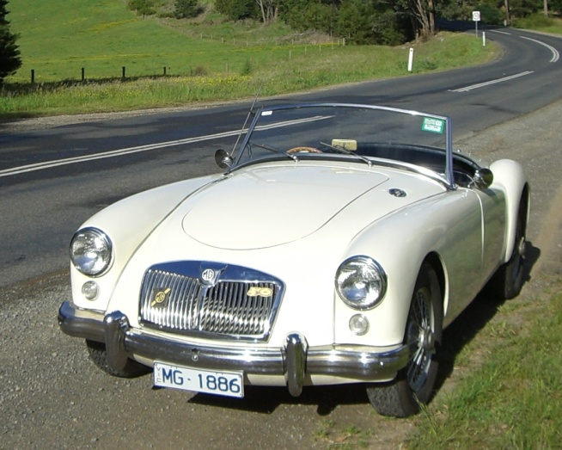
As an all-makes club, the variety of cars is one factor that makes our monthly runs so interesting. Check out the photographs on the website and you will see what we mean.

Membership of Escape Motoring Inc., is available to owners of classic sporting cars, modern two-door sports cars and at the discretion of the committee, cars with sporting attributes. Escape does however have a membership limit (250) and the acceptance of an application may depend on current membership numbers.

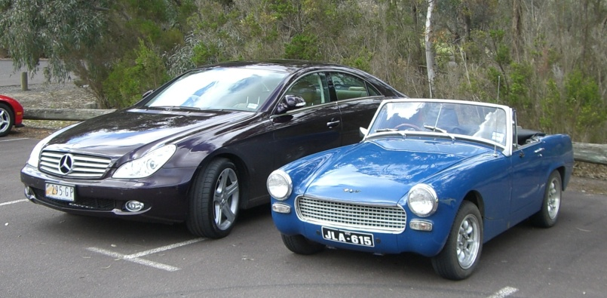
If you are interested in joining contact
our President

- president@escapemotoring.com.au

